**SARANPRATHICK M**

**727721EUIT144**

**CA-1**

**Q1:**

**package** pom.demo.demo;

**import** org.openqa.selenium.By;

**import** org.openqa.selenium.WebDriver;

//import org.openqa.selenium.WebElement;

**import** org.openqa.selenium.chrome.ChromeDriver;

**import** org.openqa.selenium.chrome.ChromeOptions;

**import** io.github.bonigarcia.wdm.WebDriverManager;

**public** **class** ca11 {

**public** **static** **void** main(String[] args) **throws** InterruptedException {

// **TODO** Auto-generated method stub

ChromeOptions co=**new** ChromeOptions();

co.addArguments ("--remote-allow-origins=*");

WebDriverManager.*chromedriver*().setup ();

WebDriver driver=**new** ChromeDriver(co);

driver.get ("https://www.amazon.in/Logitech-B170-Wireless-Mouse-Black/dp/B01J0XWYKQ/ref=pd_ci_mcx_mh_mcx_views_0?pd_rd_w=Pow0G&content-id=amzn1.sym.7938e11a-362b-421f-bd30-8dd8d3c4b65f&pf_rd_p=7938e11a-362b-421f-bd30-8dd8d3c4b65f&pf_rd_r=382BVSFQCEY6JFB1H2E2&pd_rd_wg=7ZQOA&pd_rd_r=46b47b77-6ccd-4bfc-b4e5-11a620793d54&pd_rd_i=B01J0XWYKQ&th=1");

driver.manage().window().maximize() ;

String currentTitle=driver.getTitle();

System.***out***.println(currentTitle);

String expectedTitle="Logitech B170 Wireless Mouse, 2.4 GHz with USB Nano Receiver, Optical Tracking, 12-Months Battery Life, Ambidextrous, PC/Mac/Laptop - Black ";

**if**(currentTitle.equals(expectedTitle)) {

System.***out***.println("Title Matched");

}

**else** {

System.***out***.println("Title not Matched");

}

driver.findElement(By.*xpath*("//*[@id=\"add-to-cart-button\"]")).click();

driver.findElement(By.*xpath*("//*[@id=\"nav-cart\"]")).click();

driver.findElement(By.*xpath*("//*[@id=\"a-autoid-0-announce\"]")).click();

driver.findElement(By.*xpath*("//*[@id=\"quantity_4\"]")).click();

driver.findElement(By.*xpath*("//*[@id=\"sc-buy-box-ptc-button\"]/span/input")).click();

driver.navigate().back();

driver.findElement(By.*name*("submit.delete.d70a347a-753f-4558-ba73-3564af43f50b")).click();

Thread.*sleep*(5000);

}

}

**OUTPUT:**

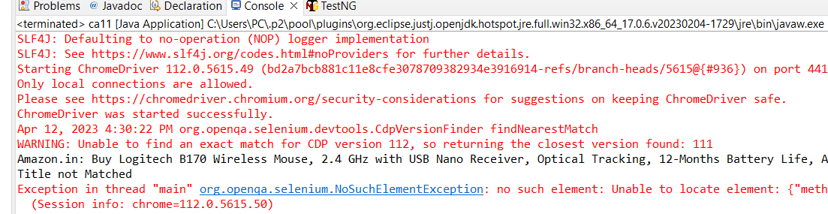

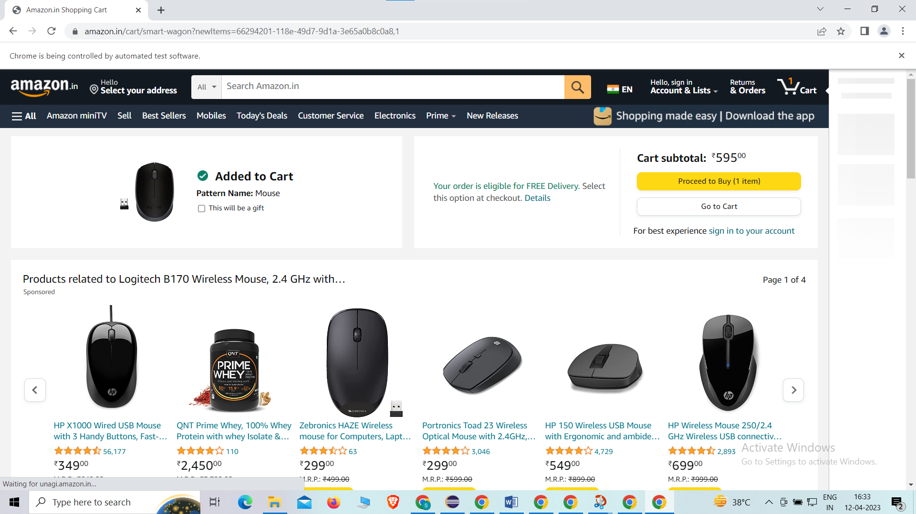

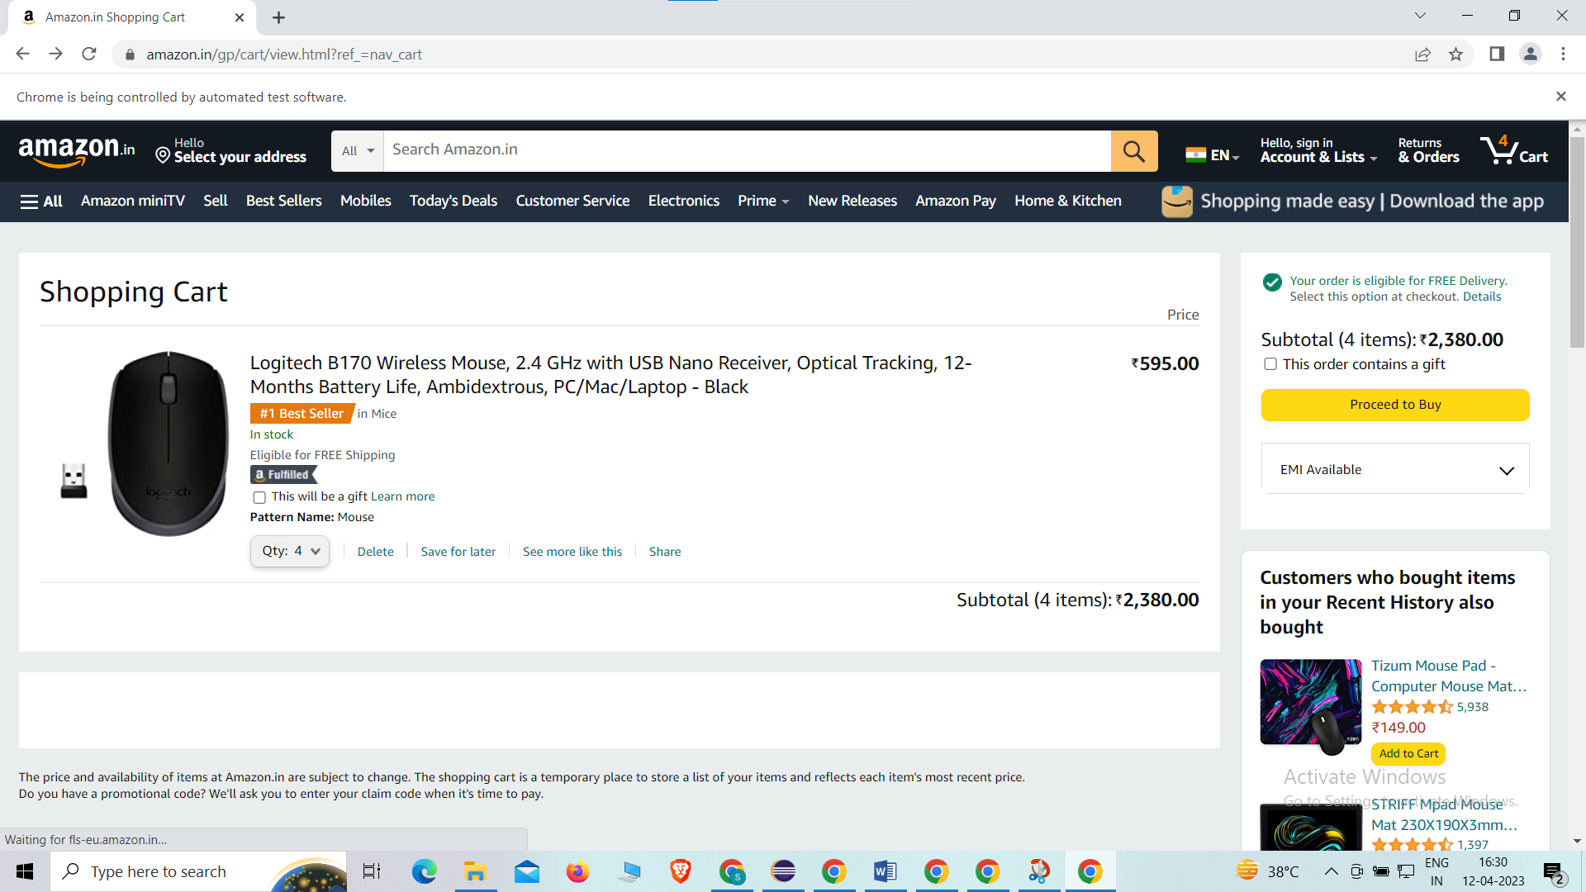

**Q2:**

**package** pom.demo.demo;

**import** org.openqa.selenium.By;

**import** org.openqa.selenium.WebDriver;

**import** org.openqa.selenium.WebElement;

**import** org.openqa.selenium.chrome.ChromeDriver;

**import** org.openqa.selenium.chrome.ChromeOptions;

**import** io.github.bonigarcia.wdm.WebDriverManager;

**public** **class** ca22 {

**public** **static** **void** main(String[] args) {

// **TODO** Auto-generated method stub

ChromeOptions co=**new** ChromeOptions();

co.addArguments ("--remote-allow-origins=*");

WebDriverManager.*chromedriver*().setup ();

WebDriver driver=**new** ChromeDriver(co);

driver.get ("https://www.amazon.in/");

driver.manage().window().maximize() ;

String currentTitle=driver.getTitle();

System.***out***.println(currentTitle);

String expectedTitle="Online Shopping site in India: Shop Online for Mobiles, Books, Watches, Shoes and More - Amazon.in";

**if**(currentTitle.equals(expectedTitle)) {

System.***out***.println("Title Matched");

}

**else** {

System.***out***.println("Title not Matched");

}

WebElement txtBoxl=driver.findElement(By.*xpath*("//*[@id=\"twotabsearchtextbox\"]"));

txtBoxl.sendKeys("macbook");

driver.findElement(By.*xpath*("//*[@id=\"nav-search-submit-button\"]")).click();

//displaying 5 products

String txt1=driver.findElement(By.*xpath*("//*[@id=\"search\"]/div[1]/div[1]/div/span[1]/div[1]/div[3]/div/div/div/div/div/div/div/div[2]/div/div/div[1]/h2/a/span")).getText();

System.***out***.println(txt1);

String txt2=driver.findElement(By.*xpath*("//*[@id=\"search\"]/div[1]/div[1]/div/span[1]/div[1]/div[4]/div/div/div/div/div/div/div/div[2]/div/div/div[1]/h2/a/span")).getText();

System.***out***.println(txt2);

String txt3=driver.findElement(By.*xpath*("//*[@id=\"search\"]/div[1]/div[1]/div/span[1]/div[1]/div[5]/div/div/div/div/div/div[2]/div/div/div[1]/h2/a/span")).getText();

System.***out***.println(txt3);

String txt4=driver.findElement(By.*xpath*("//*[@id=\"search\"]/div[1]/div[1]/div/span[1]/div[1]/div[6]/div/div/div/div/div/div[2]/div/div/div[1]/h2/a/span")).getText();

System.***out***.println(txt4);

String txt5=driver.findElement(By.*xpath*("//*[@id=\"search\"]/div[1]/div[1]/div/span[1]/div[1]/div[7]/div/div/div/div/div/div[2]/div/div/div[1]/h2/a/span")).getText();

System.***out***.println(txt5);

//filter

driver.findElement(By.*xpath*("//*[@id=\"p_36/7252032031\"]/span/a/span")).click();

driver.findElement(By.*xpath*("//*[@id=\"p_n_pattern_browse-bin/1464446031\"]/span/a/span")).click();

}

}

**OUTPUT:**

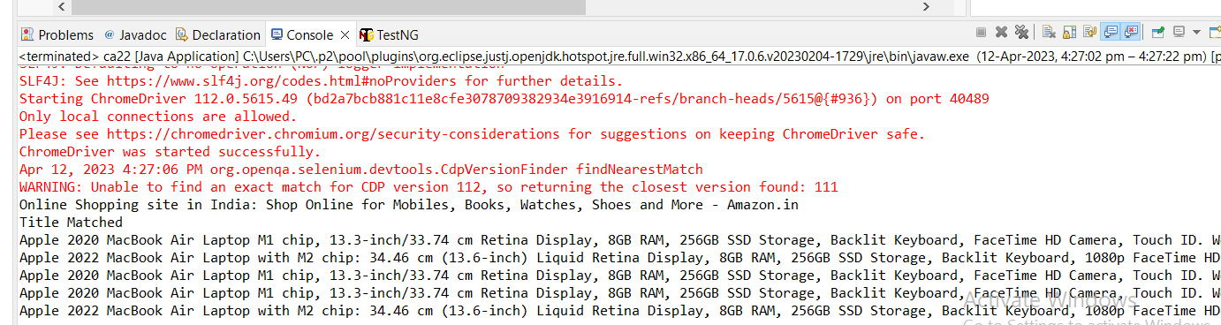

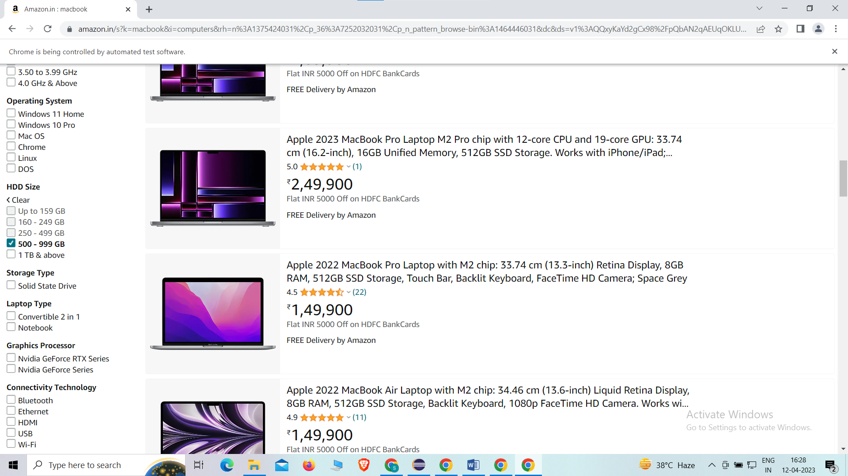

**Q3:**

**package** pom.demo.demo;

**import** org.openqa.selenium.By;

**import** org.openqa.selenium.WebDriver;

**import** org.openqa.selenium.WebElement;

**import** org.openqa.selenium.chrome.ChromeDriver;

**import** org.openqa.selenium.chrome.ChromeOptions;

**import** io.github.bonigarcia.wdm.WebDriverManager;

**public** **class** ca33 {

**public** **static** **void** main(String[] args) {

// **TODO** Auto-generated method stub

ChromeOptions co=**new** ChromeOptions();

co.addArguments ("--remote-allow-origins=*");

WebDriverManager.*chromedriver*().setup ();

WebDriver driver=**new** ChromeDriver(co);

driver.get ("https://www.amazon.in/");

driver.manage().window().maximize() ;

String currentTitle=driver.getTitle();

System.***out***.println(currentTitle);

String expectedTitle="Online Shopping site in India: Shop Online for Mobiles, Books, Watches, Shoes and More - Amazon.in";

**if**(currentTitle.equals(expectedTitle)) {

System.***out***.println("Title Matched");

}

**else** {

System.***out***.println("Title not Matched");

}

driver.findElement(By.*xpath*("//*[@id=\"nav-link-accountList\"]")).click();

WebElement txtBoxl=driver.findElement(By.*xpath*("//*[@id=\"ap_email\"]"));

txtBoxl.sendKeys("9342815715");

driver.findElement(By.*xpath*("//*[@id=\"continue\"]")).click();

WebElement txtBox2=driver.findElement(By.*xpath*("//*[@id=\"ap_password\"]"));

txtBox2.sendKeys("Saran@2003");

driver.findElement(By.*xpath*("//*[@id=\"signInSubmit\"]")).click();

driver.findElement(By.*xpath*("//*[@id=\"nav-link-accountList\"]")).click();

driver.findElement(By.*xpath*("//*[@id=\"a-page\"]/div[2]/div/div[2]/div[1]/a/div/div")).click();

driver.findElement(By.*xpath*("//*[@id=\"a-autoid-2-announce\"]")).click();

driver.findElement(By.*xpath*("//*[@id=\"ordersInPackage-container\"]/div/div/a[1]")).click();

}

}

**OUTPUT:**

